4Fiker Zewdie

Over the course of one year, the graph of median temperatures in Ardsley and Times Square give an overview of what a typical year looks like in Times Square and Ardsley. Given that the two locations are in the northeast, they experience their coldest temperatures in the winter and their warmest temperatures in the summer with more moderate temperatures in the spring and fall.

For a given year, the difference between Ardsley and Times Square temperatures was graphed. When Times Square temperatures fall above temperatures in Ardsley for most of the year, it indicates that Times Square is warmer for the most part. The most likely reason for this could be low energy consumption during spring months in Times Square.

In the Ardsley distribution, the slight shift in the mean temperatures caused a large shift in the extremes. Over the latter time period the number of temperatures that fall above the 90th percentile threshold increased.

Times Square temperatures shifted very slightly in the median, but this seemingly small shift created a large shift in the tails, making the extremes on the warmer end of temperatures more common.

In Times Square, the summer median temperature shifted slightly meaning the frequency for days to fall above Ardsley’s 90th and 95th percentiles is higher in Times Square than in Ardsley. This shift in the distribution indicates that Times Square experiences warmer summers.

In both Times Square and Ardsley, mainly because both locations were standardized with respect to their own temperature thresholds. Due to the two locations being in close proximity to each other, the variability trends are similar. In this graph, temperatures in Times Square are generally higher due to the Urban Heat Island effect.



When the number of extreme heat days for each year was graphed, it remained true that the urban heat island effect and the increase in global warming caused an increase in the temperature for the hottest day of the year. Due to the standardization of both locations to their respective thresholds, the variability of both locations remains very similar. This increase in the number of extreme heat days in both locations is a good indicator that global warming has caused for unusually warmer weather than before.

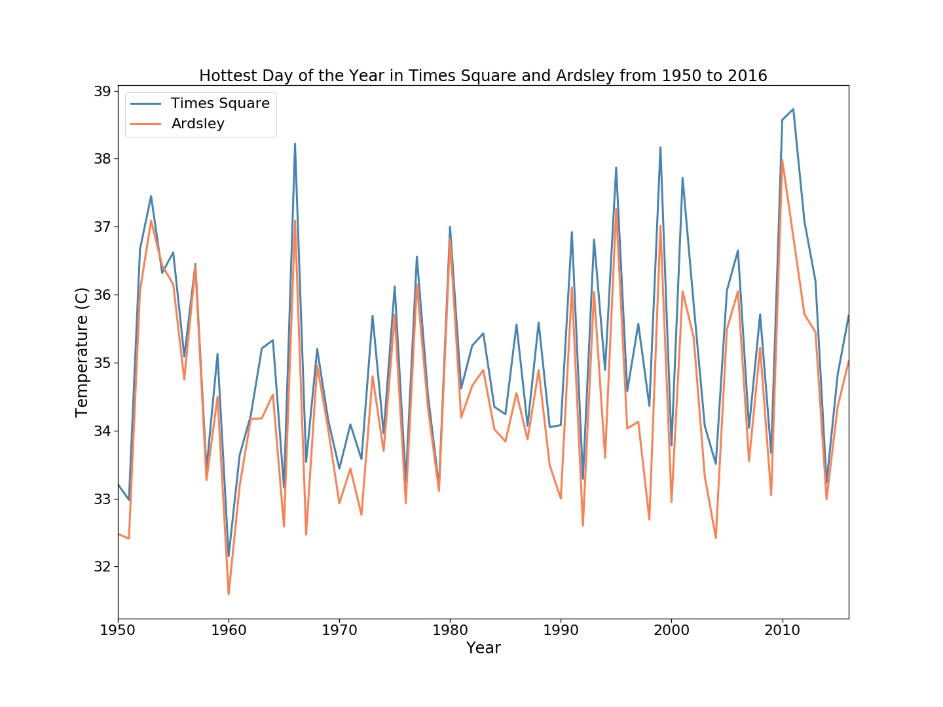

When graphing the maximum temperature of each year, variability of both Times Square and Ardsley remain similar for the first half of the timeframe. This changes after 1980 and the average temperatures increase at a faster rate in Times Square than in Ardsley.

In Ardsley, the first day of the year above the 90th percentile threshold (for the years between 1951-1987) falls earlier overtime. A statistically significant linear relationship was drawn using a linear regression model, which estimated that for every year, the first day of the year above the 90th percentile threshold would fall about half a day earlier.

In Times Square as well, the first day of the year above the 90th percentile threshold (for the years between 1951-1987) falls earlier overtime. The linear regression model drew a weaker, but helpful model that predicted that temperatures would fall above the 90th percentile threshold 0.2 days earlier each year.

The trend using all data from 1950-2016 estimates that by 2050, the temperatures will reach 29.4 degrees Celsius, while the trend considering temperatures from after 1980 estimates 28.8 degrees Celsius.

The trend using all data from 1950-2016 estimates that by 2050, the temperatures will reach 29.4 degrees Celsius, while the trend considering temperatures from after 1980 estimates 30.1 degrees Celsius.

A linear regression line was drawn to predict two probable trends for average summer temperatures. The first trend takes into account the temperatures of all years given, but the second trend takes into account the temperature data after 1980 because there was a drastic increase in the trend after 1980. The second trend may be more reliable if the trend after 1980 were to continue. Though statistically this may be considered a weak trend, this is mainly because of the natural variability from the temperature data over a much smaller time series and is the more likely trend to follow if it was assumed that the trend from 1980 forward would continue.

In Times Square a linear relationship was drawn to estimate the number of extreme heat days for a given temperature. This statistically significant line of best fit was drawn using a linear regression model that predicted on average about 8 additional extreme heat days for a degree increase in temperature.

Similarly, in Ardsley a statistically significant linear relationship was drawn that estimates about 8.6 more extreme heat days for every degree increase.